C:\Users\Mariya\AppData\Local\Microsoft\Windows\Temporary Internet Files\Content.IE5\UMZ6G0Q2\MC900437471[1].wmf

The Buzz!!

**42nd UAE National Day Celebration!**

Preparation for National Day started with decorating the class and our corridors, our corridor was looking fantabulous.

National Day Celebrations in the school were amazing! The students drew flags and decorated the class with it. A fun filled assembly was organized for all the students. The senior students had food stalls. A local dancing was also danced. Students wore dresses of UAE flag colour. We had a fun filled day!

Monthly buzz of 3A

Issue: 3 November

**Active Classroom Learning**

**Numeracy**: We learnt about rounding, doubling and halving and simple equivalent fractions.

**Science:** Now we know how the different types of teeth and their functions. We also learnt about the healthy diet.

**Geography:** We enjoyed learning about the climate, geographical features and lots more interesting facts about Switzerland and Egypt

**Arabic: أنا قمت اليوم مع صديقتى أية فى الصف برسم الشخصيات الموجودة فى فيلم شارلى ومصنع الشيكولاتة وأنا أحب شخصية شارلى لأنه يحب عائلته وليس طماع مثل باقى الأولاد بالفيلم واشتركت مع أية فى كتابة عناصر القصة**

**3Aياسمين**

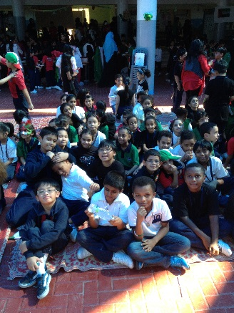

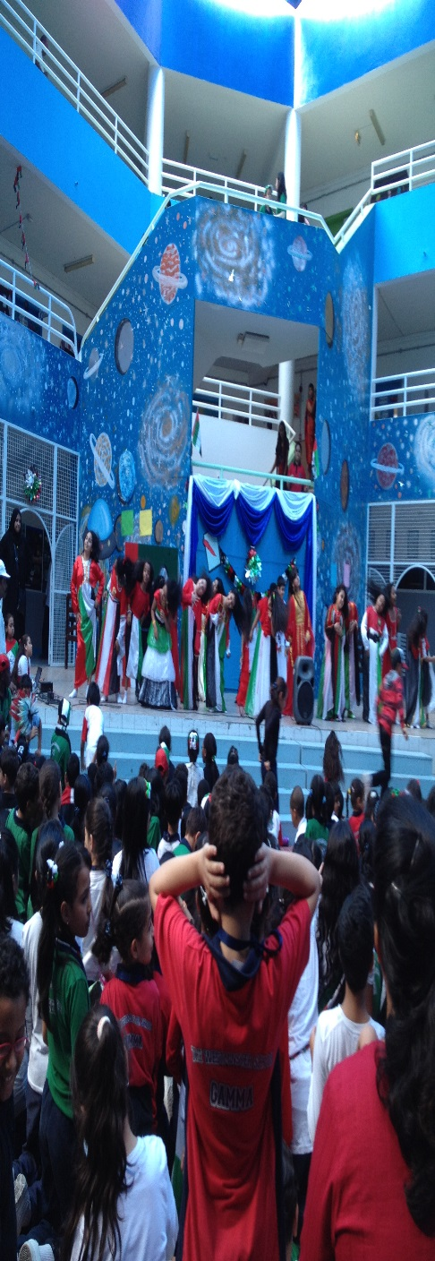

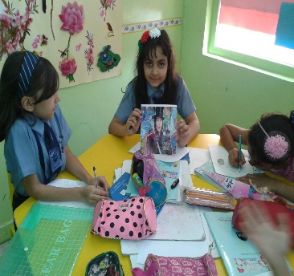

TRY THIS WEBSITE

<http://www.coolmath4kids.com>

This webpage has many fun math games. Log on and click the “Math Games” tab. There are tons of fun games! **Check it out!!** Refer the class blog as a learning tool.

<http://3aisourclass.weebly.com/>

**Star student of the month:**

Congratulations to Mohannad

## Upcoming Events:

* Open House
* Winter break…

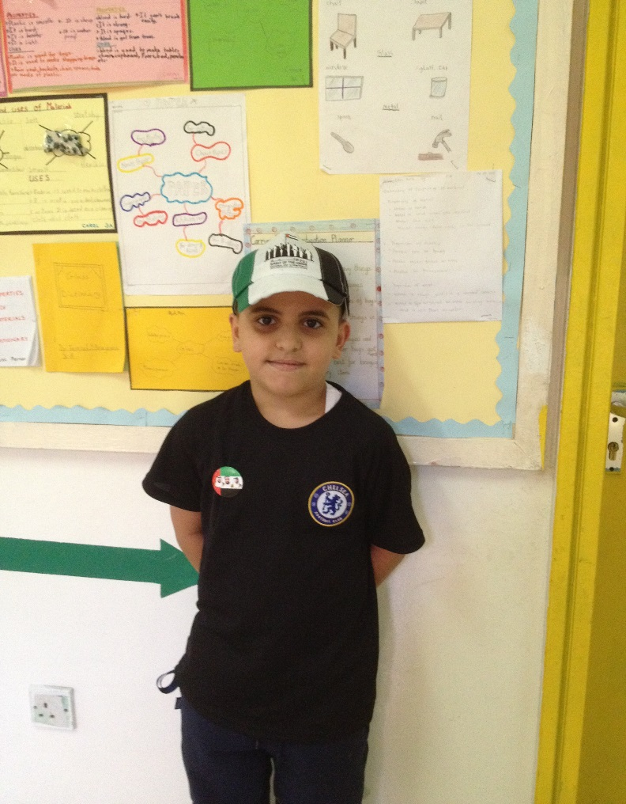

**Morning Assemblies**

It was grade 3’s turn to go down for the morning assembly. The 6th form students showed their great innovations. Wow it was!! Some of our mates in the choir!

Finally the assessments are over!!!! Yahoooooo……

Hurray!!!We are going to have a winter break!!!!!!!! It’s gonna be for 3 weeks. It will start from December 20th-8 January 12. Wish you all A HAPPY NEW YEAR as we will not get a chance to celebrate with you in school .HAVE A LOT OF FUN AND RELAX yourself as there is much more to come in 2nd term!

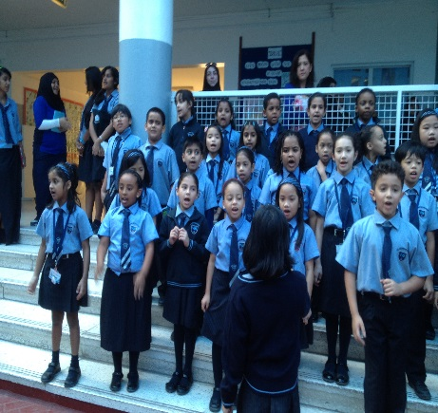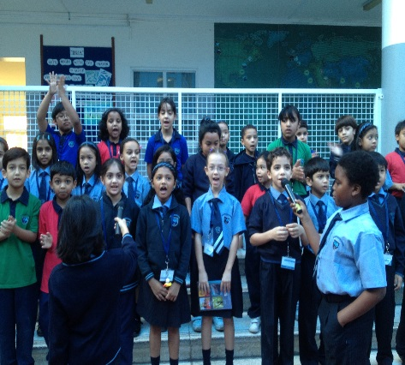

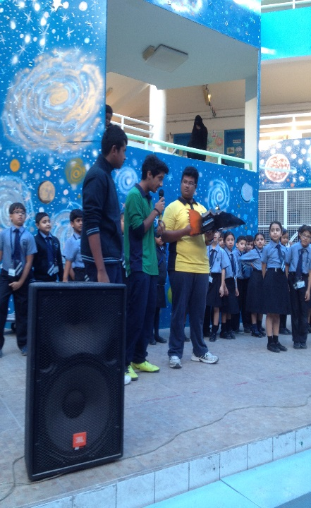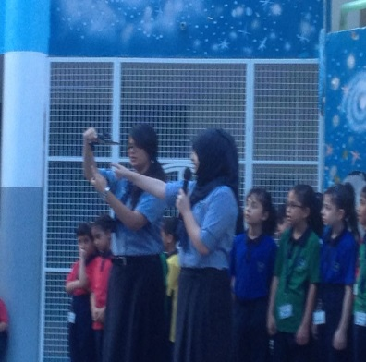

__________________________________ The Buzz___ Page 2

**Collaborative learning**

**Hands on learning**

**21st century learning**

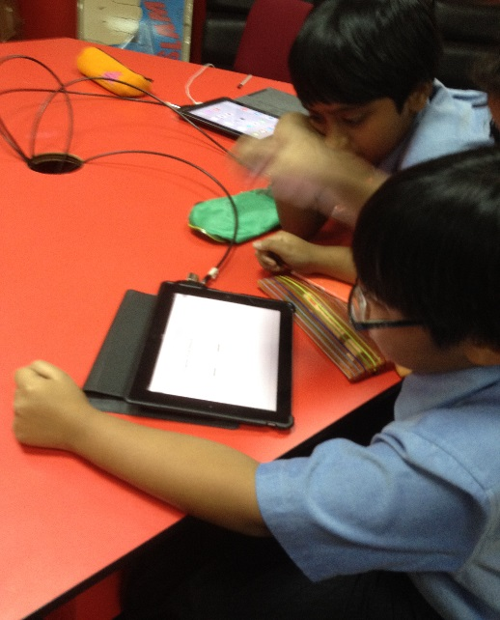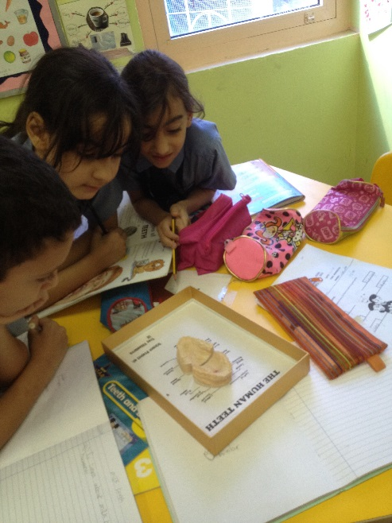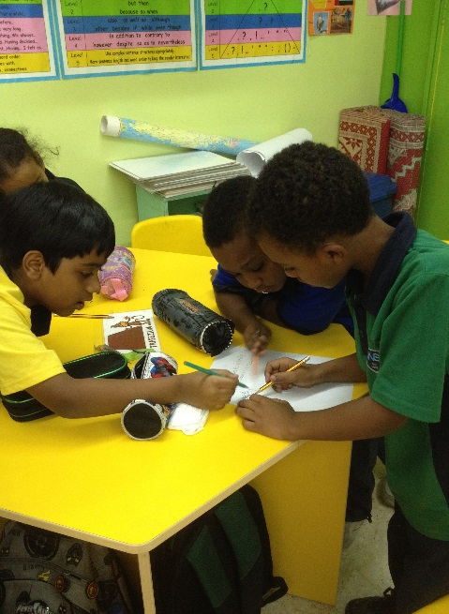

***Charlie and the chocolate factory theme based learning……*** Charlie & the chocolate factory theme based learning enhanced students to learn through new methods of learning using the theme for a more fun and interactive approach. Students experience different, new and fun learning methods. Golden ticket was sneaked into one of the chocolate bars and was sold for Dhs 2/-. Tanya from our class got through the draw and won a chance to take part in Parent-Child competitions.

Our music smart group made a wonderful song about chocolates during the smart period.

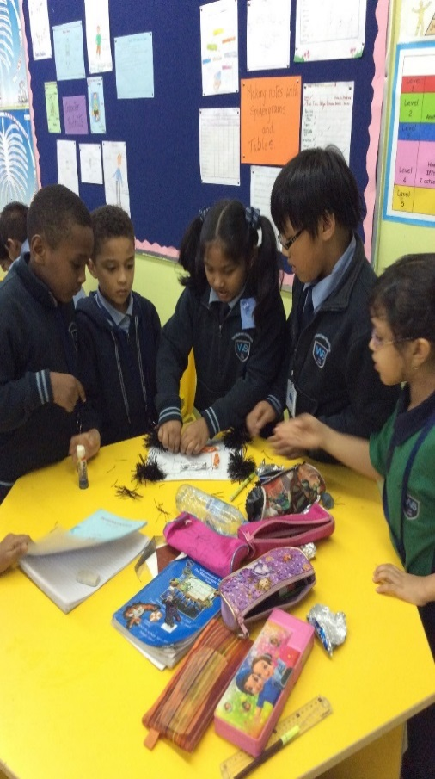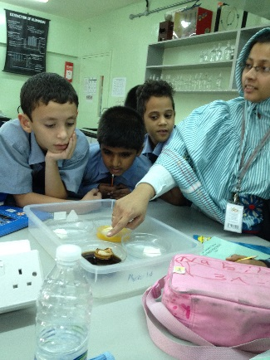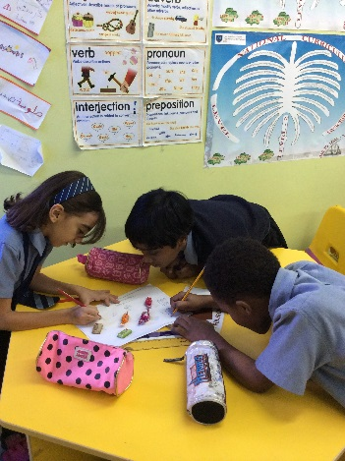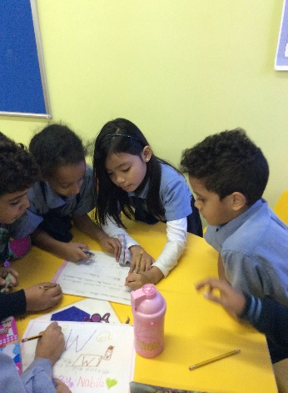

Number smart group

Body smart group

Music smart group

Experiment on tooth decay.

We learnt how bacteria causes tooth decay. We used the eggshells to understand the concept.

**By the Bees of 3A with Ms. Mariya**