C:\Users\Mariya\AppData\Local\Microsoft\Windows\Temporary Internet Files\Content.IE5\UMZ6G0Q2\MC900437471[1].wmf

Ms. Mariya’s classroom connection!

Monthly buzz of 3A Vol:2

October

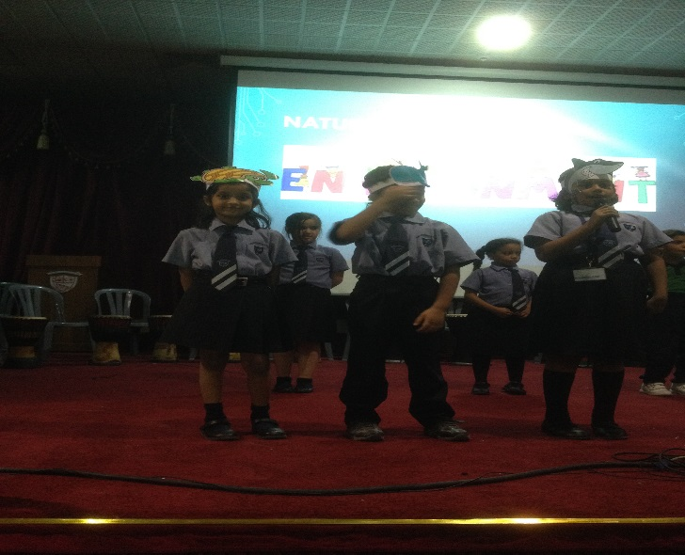

Multiple Intelligence Assembly

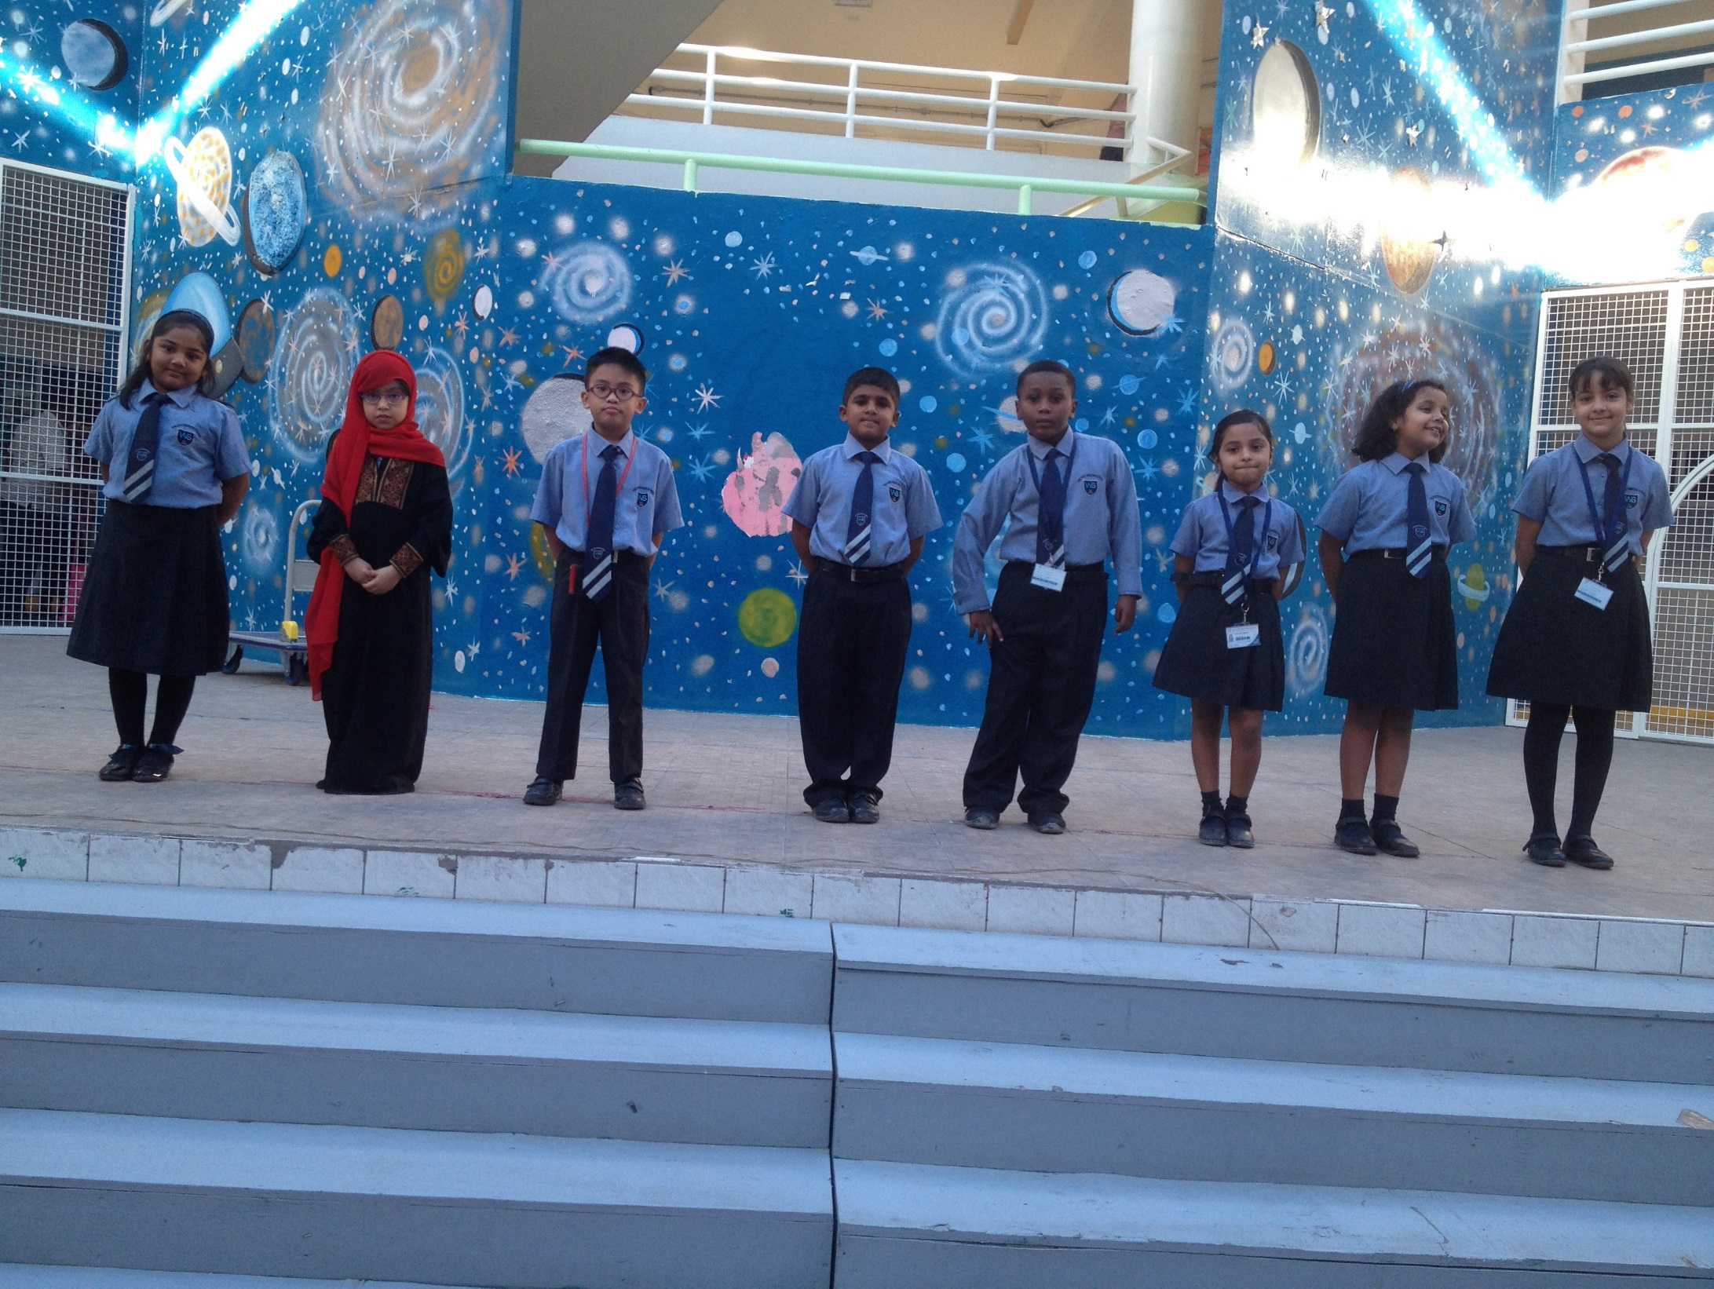

For the first time Grade three had an assembly on Multiple Intelligence. Theme was given as Water. Students showed their colours with enthusiastic participation.

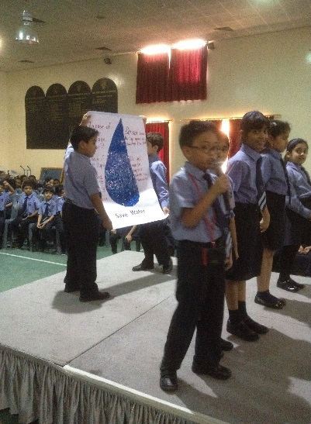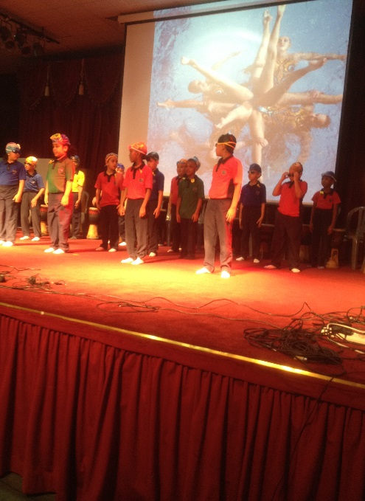

**Star Student of the Month**

Tanya Biju.

Attendance for Month of October

Coming up next!!

Garage Sale

Objective of this event is to learn to do charity and contribute towards the needy people around the world. Money Collected will be deposited to a charitable organization.



**Active Classroom Learning**

**Literacy: -** We learnt how to write a report on garden birds, Verb Tenses, Speaking loud and clear and speech verbs.

**Numeracy: -** We learnt three digit numbers, addition facts of 10 and 20,2D shapes, length and now we know to tell the time.

**Geography: -** We enjoyed learning about, how hot and cold places are and about the Changing scene.

**Science: -** We got the opportunity to learn and understand a lot more aboutmaterials and its properties. We conducted various experiments and observations on materials. We are currently learning about Teeth and Eating.

**History: -** We are learning about Ancient Greek Architecture.

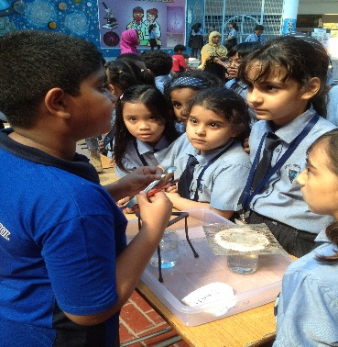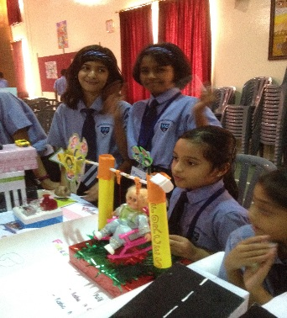

Science Day