Ms. Mariya’s classroom connection!

C:\Users\Mariya\AppData\Local\Microsoft\Windows\Temporary Internet Files\Content.IE5\UMZ6G0Q2\MC900437471[1].wmf

Monthly buzz of 3A

Issue – 4 Dec-Jan

***From the editor,***

**Welcome back again to the 4th edition of our class Newsletter.**

**We ended the year with the, Assessments, an educational trip and the Open house.**

**The New Year has started very energetically with preparations for the**

**Sports Day!**

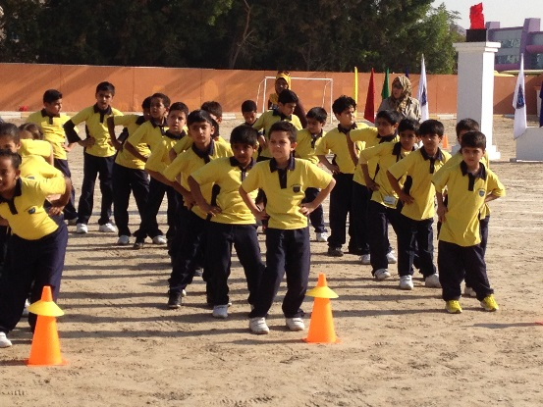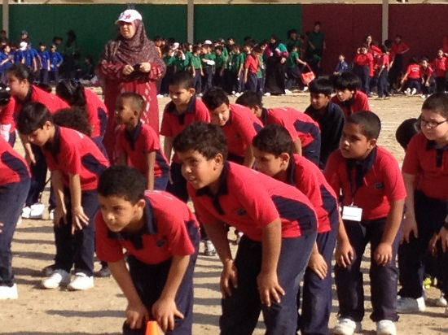

Sports Day

It was a day full of fun, excitement, and all the children were full of energy. We enthusiastically participated in the events and some of us won medals. Children are in action actively performing the drill during the Sports Day. Sigma house took the victory trophy home Sigma house again won the best cheer walk even. They also set an exemplary behaviour during the event and won the best behaviour trophy too! Beta house took the runner up cup.

Students got the privilege to free the pigeons. For the first time primary band team was prepared by Ms. Kekashan with the help of few seniors students. Range of events were skilled with multiple intelligence. Cheer walk and fusion dance is one of the examples.

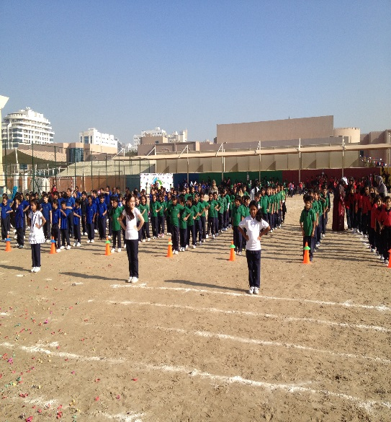

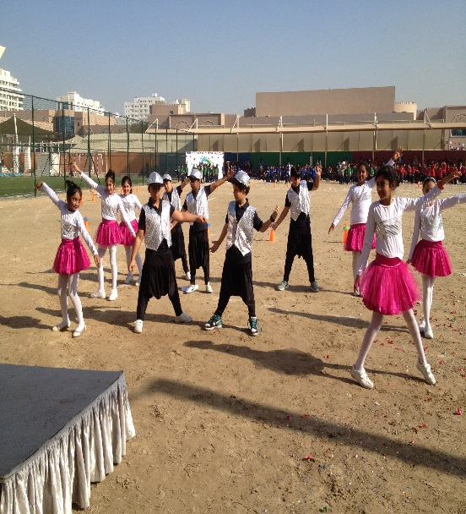

TRY THIS WEBSITE

<http://www.e-learningforkids.org/>

This webpage has many e learnings. Log on explore all the subjects tab. There are tons of e learning!

<http://3aisourclass.weebly.com/> Find more pictures of sports day and other events on our class blog.

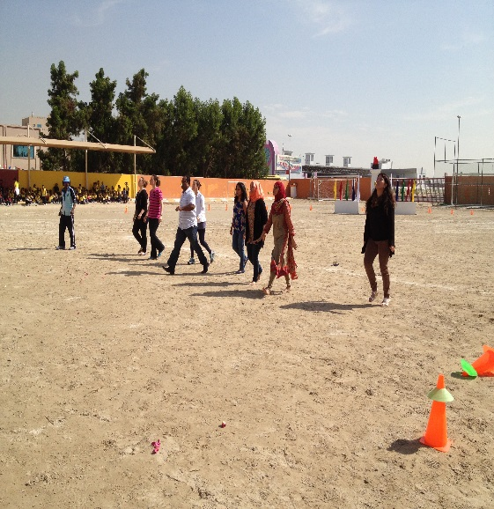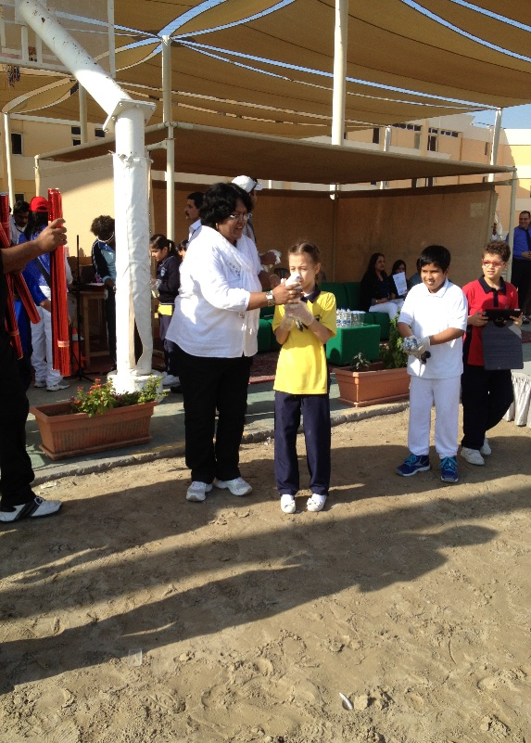

Parents’ race-lemon and spoon

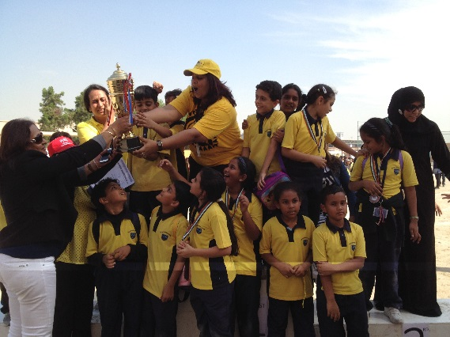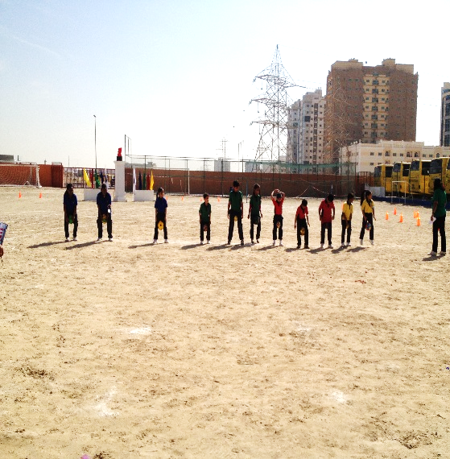

Novelty race- Tuck in ball

Ms. Mariya’s classroom connection Nov-Dec 2014 Page 2

**Curriculum**

**English:** We are learning about different types of Stories.

**Math:** We learnt about odd and even numbers , prisms and 3D shapes, Addition and Subtraction

**Science:** we learnt the uses of many different magnets. We investigated which was the strongest magnet.

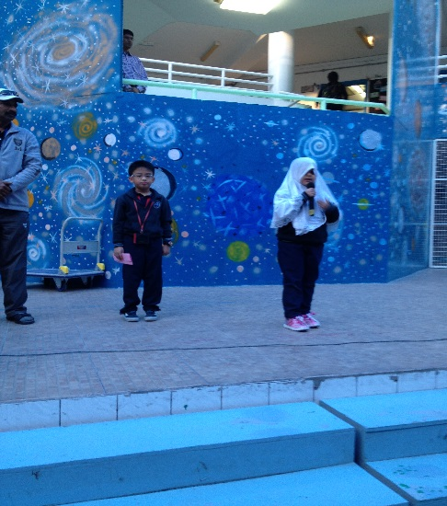

ATTENDANCE SUMMARY DECEMBER 2013

ATTENDANCE SUMMARY - January 2014

Morning Assembly by 3A Kenzy recited the Quran while Sebastien said the quote of the day.

**Happy Birthday to**

Izzat and Menatalla

**Star of the month**

December- Carol

January-Sebastien

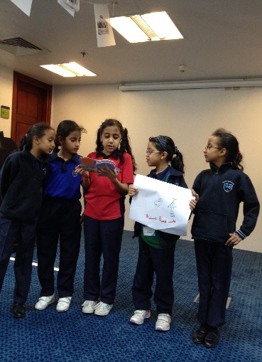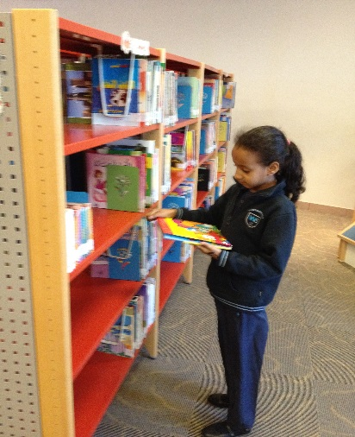

**Field Trip**

We had a great educational field trip to Dubai public library. We coloured and read the story books. We were asked to describe the imagination after reading the book which was given to us. It was great fun. I and my friends enjoyed the short stay at the library.

By Sumaiyya Ibrahim saad

By the bees of 3A and our teacher Ms Mariya.