C:\Users\Mariya\AppData\Local\Microsoft\Windows\Temporary Internet Files\Content.IE5\UMZ6G0Q2\MC900437471[1].wmf

Ms. Mariya’s classroom connection!

***Congratulations!!!***

*Mr. Kingston for being our New Principal.*

*Ms. Vijyakumari for our New Vice-Principal.*

Monthly buzz of 3A Vol:1

**Dear parents,**

Welcome to our first edition of our newsletter ‘’Ms. Mariya’s class room connection’’. This will help you to know all about the current happenings of our Learning Bay.

Class council

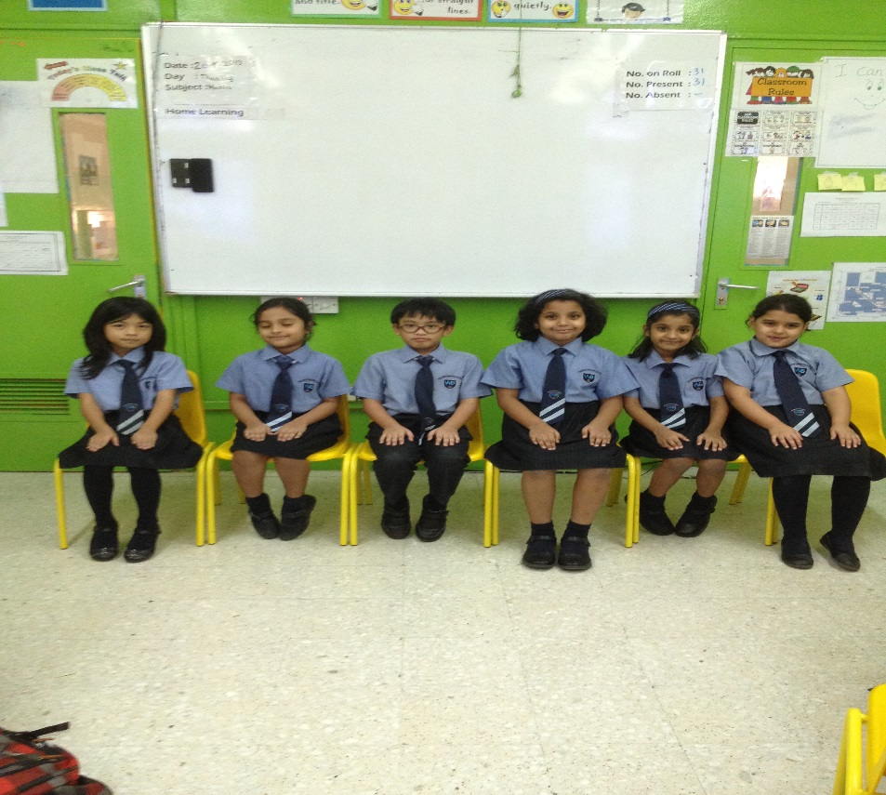

Welcome Back!!!

After a long break, now back to school!! All the year 3 children held a lovely assembly to welcome all new teachers and our new friends. 3E and 3F had an assembly for us. We sang songs and cheered our new friends and teachers!!

**Class Blog**

Visit our class blog and find the live happenings.

[**http://3aisourclass.weebly.com/index.html**](http://3aisourclass.weebly.com/index.html)

President-Sebastien Vice-president- Carina Prefect- Tanya Monitor- Carol House secretary – Kenzy Student Welfare- Kristen

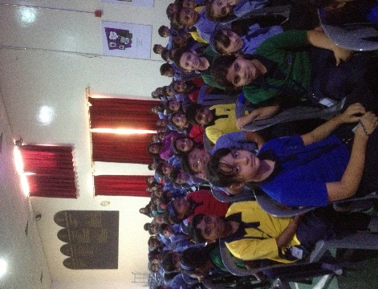

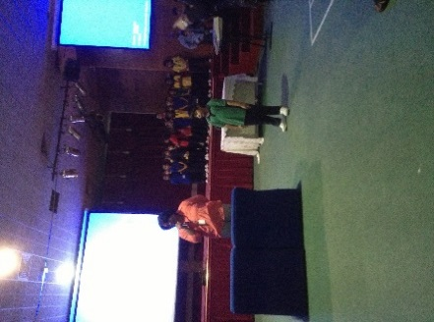

**Active Classroom Learning**

**Literacy: -** We learnt how to write a report on garden birds, Verb Tenses, Speaking loud and clear and speech verbs.

**Numeracy: -** We learnt three digit numbers, addition facts of 10 and 20,2D shapes,

**Geography: -** We enjoyed learning about the World, the continents, oceans, how hot and cold places are and about the Changing scene.

**Science: -** We got the opportunity to learn and understand a lot more aboutMaterials and its properties. We conducted various experiments and observations on materials. We investigated the most absorbent paper and best nappy for babies.

What a day!!! WOW!!.....

Like every year our first day to school was WOW! Colourful walls and new lovely hexagonal furniture was eye catching. We were engaged in activities, some of us drew and wrote articles about our summer break and some of us designed our names on a paper. Multiple Intelligence was introduced to us.

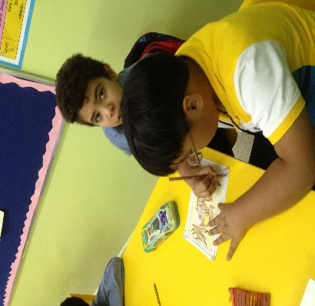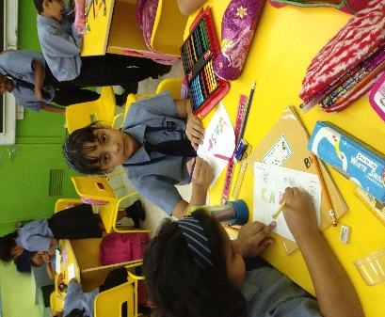

**Year 3 September Attendance**