[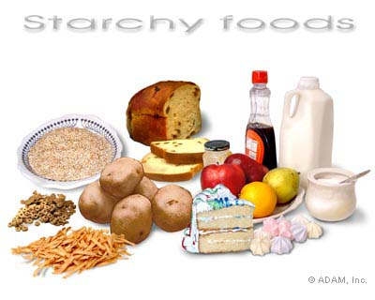](http://www.google.ae/url?sa=i&rct=j&q=&esrc=s&frm=1&source=images&cd=&cad=rja&docid=16I0N_kf-aXiLM&tbnid=oYQeUapHbZx5DM:&ved=0CAUQjRw&url=http://www.nytimes.com/imagepages/2007/08/01/health/adam/19824Starchyfoods.html&ei=Fc1vUtztDc3LsgaFlYHoBQ&psig=AFQjCNEJzoCSaCejpvio-DvUEHvn5zIDAQ&ust=1383145052275279)

Food for Activity

[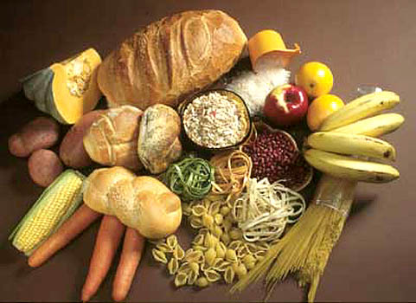](http://www.google.ae/url?sa=i&rct=j&q=&esrc=s&frm=1&source=images&cd=&cad=rja&docid=sWlJLTFWc5C7gM&tbnid=xU6wWL-YCzbAuM:&ved=0CAUQjRw&url=http://lhbs.edu.vn/&ei=j81vUrbjDcPeswaCpoGYAQ&psig=AFQjCNEJzoCSaCejpvio-DvUEHvn5zIDAQ&ust=1383145052275279)

[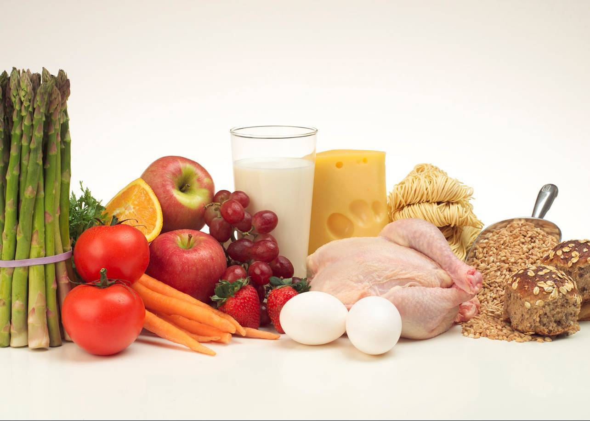](http://www.google.ae/url?sa=i&rct=j&q=&esrc=s&frm=1&source=images&cd=&cad=rja&docid=dsW-Hr397LiYnM&tbnid=4bkYlyxfbMS4tM:&ved=0CAUQjRw&url=http://www.fantasticelements.com/2013_05_01_archive.html&ei=YM5vUoaOIcWatQaE9IFQ&psig=AFQjCNHS7-5Pa0mnNBaJVsClmYNuxttwig&ust=1383145402471345)

Food for growth

[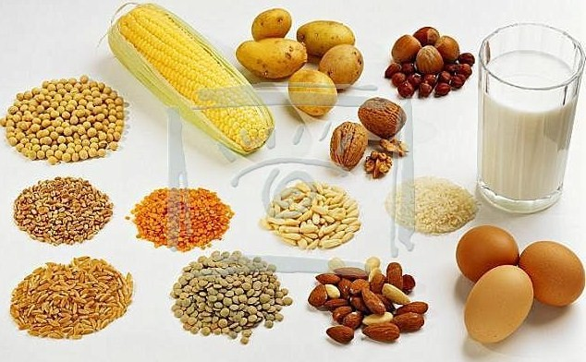](http://www.google.ae/url?sa=i&rct=j&q=&esrc=s&frm=1&source=images&cd=&cad=rja&docid=dsW-Hr397LiYnM&tbnid=4bkYlyxfbMS4tM:&ved=0CAUQjRw&url=http://mobile-cuisine.com/features/meatless-mondays-finding-protein-on-a-food-truck-without-ordering-meat/&ei=f85vUvmcGIrctAaTjoHQBg&psig=AFQjCNHS7-5Pa0mnNBaJVsClmYNuxttwig&ust=1383145402471345)