The Westminster School, Dubai
Ancient Greek Alphabet
The Greek alphabet is over 2500 years old! Even though it is very old, it still works. People living in Greece today use this alphabet to make words, just as we use our alphabet to make words.
Many people think the idea of an alphabet is an ancient Greek invention, but the Greeks borrowed their alphabet from another culture, the Phoenicians. The Greeks traded with the Phoenicians. When they saw the Phoenicians writing things down, they thought that was very clever. The Greeks could easily see the usefulness of a written language.
They changed the Phoenician alphabet a bit to suit themselves. For one thing, they added vowels. The Greek alphabet was the first alphabet to include vowels.
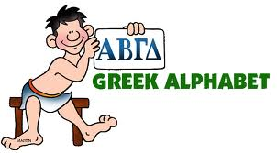
Once they had a written language, the ancient Greeks began to write down all their fables and myths and legends. They wrote letters to each other that shared their daily life. They wrote business contracts. They kept reports of meetings. They wrote huge epics and wonderful stories and plays.
One of the many gifts we received from ancient Greece was our alphabet with vowels. The word "alphabet" is a made-up word that combines the first two letters of the Greek alphabet - alpha and beta - alphabet.
Like the ancient Greeks ,we also made some changes. We changed the look of the letters. We changed the way we said the letters out loud. Over time, we even changed the order of the letters. In our English alphabet, the first three letters are ABC. In the Greek alphabet, the first three letters are ABG!
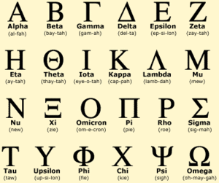
The letters are:
Alpha, Beta, Gamma, Delta, Epsilon, Zeta,
Eta, Theta, Iota, Kappa, Lambda, Mu,
Nu, Xi, Omicron, Pi, Rho, Sigma, Tau, Upsilon, Phi, Chi, Psi, Omega.

