Meat, fish and alternative
Fruits and vegetables
Cereals and starchy vegetable
Task sheet 2

Healthy eating
Obj: To understand the importance of balanced diet

Fats
Sugars
Butter
Cheese
Chips
oil
Fizzy drinks: pepsi,soda
Sweets
Cake

W/J/R: Complete task sheet 2

J/W: What is a diet?
Ans: Everything we eat is called our diet.

J/R: What is a balanced diet?
Ans: A balance diet includes food for growth and food for activity.
W/J/R: What type of food give us energy to be active?
Ans. Sugars, fat and starches give us energy to be active.
E: Make a different menu for
- An active adult
- you

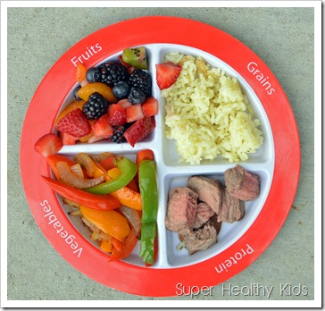
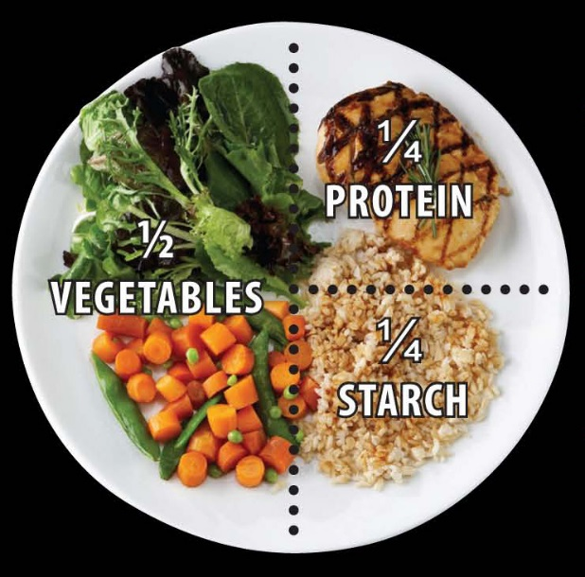
meal for kids Meal for an adult

H.L Draw or stick the food wheel. (can take help from the internet)

Carbohydrates: Energy giving food
ex: bread, pasta, rice, cereals
Fats: store of energy giving in body. Slow energy
Sweets, candy, chocolates, oil…
Proteins: body building and repairing.
Ex: milk, fish, chicken, meat..
Vitamins and minerals: Keeps body healthy and fights diseases.
Ex: fruits and vegetables
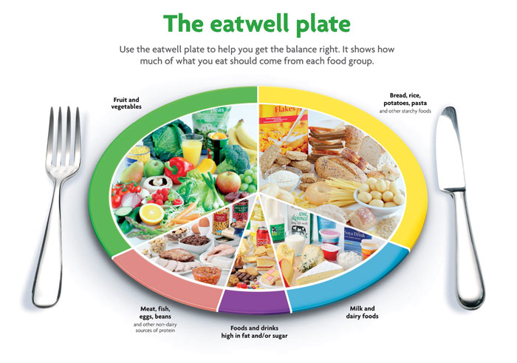
Water: Keeps our body clean and helps in digestion.

