C:\Users\Mariya\AppData\Local\Microsoft\Windows\Temporary Internet Files\Content.IE5\UMZ6G0Q2\MC900437471[1].wmf

Monthly buzz of 3A Vol: 4

February

Ms. Mariya’s classroom connection!

“When you know better you do better.”

[like](http://www.goodreads.com/user/new)

[Maya Angelou](http://www.goodreads.com/author/show/3503.Maya_Angelou)

“When you know better you do better.”

**Congratulations!!!**

Star student of the month-

Sumaiyya, Carina

Number Expert Award- Lawrence

Terrific Writer Award- trevenna

Incredible Growth Award- Ezzat and Gerard

Good Friend Award- Carol

Enthusiastic Participant Award-Josiah

The Emily Post Award- Mohannad

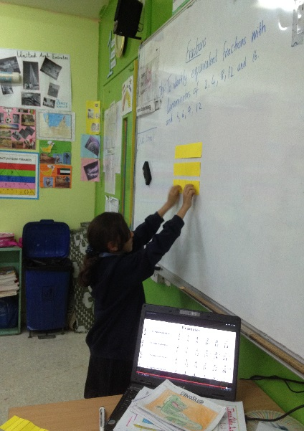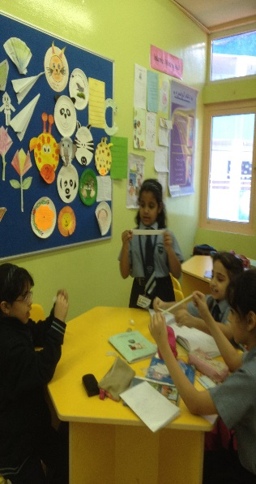

**Curriculum**

**English:** We are learning about mystery and adventure stories. Use of adjectives and Shape poems.

**Math:** We learnt about fractions, times tables, Frequency tables rounding, and additions.

**Science:** We learnt about how different magnets and springs work and now we are learning about different sources of light.

**Geography:** We are learning about how to decide our journey and about the causes, advantages and disadvantages of floods!

C:\Users\Mariya\AppData\Local\Microsoft\Windows\Temporary Internet Files\Content.IE5\Y144PITX\MC900389772[1].wmf

WEBSITE OF THE MONTH

<http://www.makemegenius.com/>

This webpage for Kids of primary school (K8 & K12 grades/level) can learn various science subjects through animated videos & movies in which cartoons characters teach.

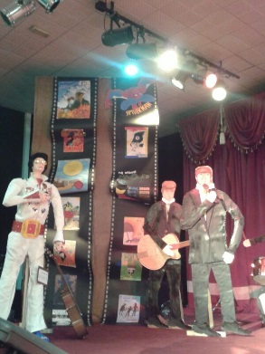

Art Exhibition

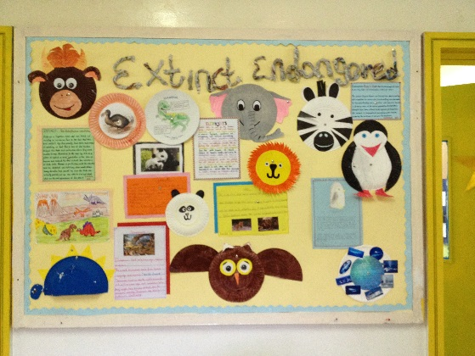

Attendance For the month of February

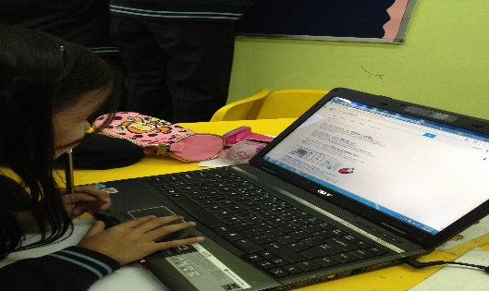Pe